

***BHARATI VIDYAPEETH***

***(Deemed to be University) Pune***

***YASHWANTRAO MOHITE COLLEGE OF ARTS, SCIENCE &***

***COMMERCE, ERANDWANE, PUNE-411038***

Accredited with ‘A+’ Grade (2017) by NAAC

Category-I University status by UGC

‘A’ Grade University status by MHRD, Govt. India

A Mini Project Report on

“OMNAS PROPERTY PORTAL”

For Partial fulfillment of

BSc. (Computer Science)-SEM-VI

DEPARTMENT OF COMPUTER SCIENCE

SUBMITTED BY

Mr. Omkar Nitin Dhadve

UNDER THE GUIDANCE OF:

Mrs. Yogita Bhapakar

For Academic Year

2024-2025



***BHARTI VIDYAPEETH***

***(DEEMED TO BE UNIVERSITY)***

**YASHWANTRAO MOHITE OF ARTS, SCIENCE & COMMERCE**

**Erandwane, Pune-411038**

Accredited with ‘A+’ Grade (2017) by NAAC

Category-I University status by UGC

‘A’ Grade University status by MHRD, Govt. India

**CERTIFICATE**

This Is To Certify That PRN NO.**2001020005**, ***Mr. Omkar Nitin Dhadve*** Of **B.Sc. (Computer Science)** Semester **VI** internship Has Satisfactorily Completed The Project On

**"OMNAS PROPERTY PORTAL**" For The Degree Of Bachelor In Computer Science of Bharati Vidyapeeth (Deemed to be University) for the Year 2024-2025

**( Mrs. Yogita Bhapakar) (Dr. Mrs. S.S. Shukla) (Dr.V.A.Rankhambe)**

**Project Guider Head of dept. Principal In charge**

Internal Examiner Internal Examiner

**INDEX**

|  |  |  |
| --- | --- | --- |
| **No** | **TITLE** | **PAGE NO** |
| 1 | AKNOWLEDGEMENT |  |
| 2 | INTRODUCTION |  |
| 3 | SYSTEM ANALYSIS AND DESIGN |  |
| 4 | EXISTING SYSTEM |  |
| 5 | PROPOSED SYSTEM |  |
| 6 | SCOPE OF SYSTEM |  |
| 7 | LITERATURE REVIEW |  |
| 8 | FEASIBILITY STUDY |  |
| 9 | REQUIREMENTS |  |
| 10 | SCREENSHOTS |  |
| 11 | CONCLUSION |  |
| 12 | BIBLIOGRAPHY |  |

**ACKNOWLEDGEMENT**

The project “Omnas Property Portal” is an original work of mine. But We would never have able to complete it alone on my own. We always needed help an support to complete it. This help and came in many forms from different people. We have opportunity to express my profound sense of gratitude and respect to all those who helped me throughout the duration of this project.

First of all, we would like to thanks our teacher “Mrs. Yogita Bhapakar Mam” under whose guidance We complete this project without his support, we were literally impossible to complete it. Her guidance was like a streak of light on a no-moon night to me. It was immense importance. It was he who explained the topic in detail to us, told me about making this project presentable.

We would also thanks to all who have helped us directly and indirectly at time of need.

**By**

**-Omkar Nitin Dhadve**

**INTRODUCTION**

Real estate is a type of business for selling, buying, renting land, buildings and offices. Real estate agencies duties include, to give the property on rent or else to sell the property. Properties like building, retail sites, flats, houses, bungalows etc. Many people search for property for many purposes like residence, offices, faculty and etc. Every individual wants his house to be in the best location with best facilities. Offices should be near market area in order to increase sales and productivity. The manual real estate agency follows a lengthy and hectic process. People need to meet the agent in person, for checking the Property details and also needs to visit the location. it takes long time to look for the desired location and desired type of property. Thus, We proposed a Omnas Property Portal to overcome this difficulty. This online Property management system can help you to get best property by just sitting at home or anywhere. People can book their favorite property online just after a few clicks. In this system the owner can add the property for selling/ renting purpose and users can buy or book a property for rent.

This system has two modules namely, Admin and User. Admin can add the property details for buildings, retail sites, flats, houses, bungalows. Admin can also add the advertises of properties. Users need to register and then login just by using credentials.

Users can view the properties for rent or for buying purpose. He/ she can mark the favourite properties and can also book appointment for visiting the viewed favourite places.

**AIMS & OBJECTIVES**

1. Seeping record of properties available
2. Stores & gives details of properties
3. Maintaining record of customers visited his website
4. Displays information of customers.
5. Displays information properties.
6. Displays information of location.
7. Displays information of location placed by customer.



**Existing System**

* **Real Estate The Current/Existing System:**

1. All the above-mentioned tasks are taken care off manually.
2. The details of all the Properties, customers, stocks and feedbacks are maintained in separate registers.

* **Limitations of the Current/Existing System:**

1. Maintaining details of the customers in registers is a time-consuming process and error-prone.
2. If a particular record is to be searched then one has to search through a lot of physical records.
3. No Security has been provided to the data.
4. As the work is manual it consumes lot of time and energy.
5. There is no facility provided for online booking of property

* **Drawbacks of the Current/Existing system To the Admin:**

1. At present everything is taken care-off manually. The admin does not have access to the information that is generated by the Developer.
2. And because the work is done manually there is area possibility of the information being error-prone.
3. Thus the admin is not in a position to make quick decisions.

**PROPOSED SYSTEM**

* **Proposed System Feature:**

1. The proposed system is developed using PHP, HTML, JAVASCRIPT, XAMPP SERVER, My SQL DATABASE. The proposed system deals with very popular World Wide Web (www) i.e. Internet.

2. The database is used i.e. XAMPP My SQL SERVER is very faster well designed tool to the user for quick manipulation with it.

3. The proposed system has better both Input/output capabilities of each the user activities while interacting with the system.

4. The search/retrieval of the properties/flats is much faster than the present system. Hence it cause to saving time for the further work.

5. The user can have fast interaction with the system by inserting keywords at there specific places, by clicking on the buttons or links etc. Because not only the front end provides the faster interaction with the records but with back end also provides the proper interaction with the records and gives or prompts the information to the end user if he is making error during work.

6. Searching feature is quite faster than current system. Because it searches directly from system that is from the front end.

7. The most important feature of this system is online exhibiting the properties, This saves time to visit at the actual place where the property is located.

8. Feedback feature is included which will helps in keeping attention on customer’s needs and requirements. The customer can have user friendliness with the system by allowing him to leave his response, advice or opinion about this system, comments on services provided by the system.





**SCOPE OF THE SYSTEM**

The Omnas Property Portal is a Website design to handle the basic tasks of the Real Estate. Hence the main function of this system or company is to convert the manual trading service of properties / flats in the better quality service that customers want.

The functionality of this system is as like handling the properties or property management and handles the main function that mentioned above.

The functionality of this system is described as follows:

1. Allows the customers to view or get details of various properties/flats available.
2. Add the properties/flats to the stock.
3. Allow admin to checks the availability of properties/flats.
4. Customer can view all properties/flats online.
5. Displays the details like customers details, rates of flats, locations, remarks details etc.

This is all the functionality of the Omnas Property Portal Website.



**FEASIBILITY STUDY**

Preliminary investigation examine project feasibility, the likelihood the system will be useful to the organization. The main objective of the feasibility study is to test the Technical, Operational and Economical feasibility for adding new modules and debugging old running system. All system is feasible if they are unlimited resources and infinite time. There are aspects in the feasibility study portion of the preliminary investigation:

1. Technical Feasibility
2. Operational Feasibility
3. Economical Feasibility
4. **TECHNICAL FEASIBILITY:**

The technical issue usually raised during the feasibility stage of the investigation includes the following:

1. Does the necessary technology exist to do what is suggested?
2. Do the proposed equipment’s have the technical capacity to hold the data required to use the new system?
3. Will the proposed system provide adequate response to inquiries, regardless of the number or location of users?
4. Can the system be upgraded if developed?
5. Are there technical guarantees of accuracy, reliability, ease of access and data security?

Real Estate various entities in order to facilitate all concerned users in their various capacities or roles. Permission to the users would be granted based on the roles specified. Therefore, it provides the technical guarantee of accuracy, reliability and security. The software and hard requirements for the development of this project are not many and are already available in-house at NIC or are available as free as open source. The work for the project is done with the current equipment and existing software technology. Necessary bandwidth exists for providing a fast feedback to the users irrespective of the number of users using the system.

1. **OPERATIONAL FEASIBILITY:**

Proposed projects are beneficial only if they can be turned out into information system. That will meet the organization’s operating requirements. Operational feasibility aspects of the project are to be taken as an important part of the project implementation. Some of the important issues raised are to test the operational feasibility of a project includes the following: -

1. Is there sufficient support for the management from the users?
2. Will the system be used and work properly if it is being developed and implemented?
3. Will there be any resistance from the user that will undermine the possible application benefits?

This system is targeted to be in accordance with the above-mentioned issues. Beforehand, the management issues and user requirements have been taken into consideration. So there is no question of resistance from the users that can undermine the possible application benefits. The well-planned design would ensure the optimal utilization of the computer resources and would help in the improvement of performance status.

1. **ECONOMICAL FEASIBILITY:**

A system can be developed technically and that will be used if installed must still be a good investment for the organization. In the economical feasibility, the development cost in creating the system is evaluated against the ultimate benefit derived from the new systems. Financial benefits must equal or exceed the costs.

The system is economically feasible. It does not require any addition hardware or software. Since the interface for this system is developed using the existing resources and technologies available at NIC, There is nominal expenditure and economical feasibility for certain.



**LITERATURE REVIEW**

In older days when we want purchase a property we can’t directly communicate with the owners. We must contact with the help of mediators, but the mediators takes lot of amount and it is also time consuming process. In older days the property dealing procedure consist of many steps like finding agent, appoint correct meeting time, location and so on. Up till now there was no Security in Online Real Estate System, Registration form improves the security by limiting user.

The existing sites are:

1. www.99acres.com: The site can be navigated by anybody. No issue of Security is implemented.

2. www.indiaproperty.com: It was launched in 2006.

These websites provide features like search property, add property and gives different offer which will be beneficial to user. But even with these features there are certain required aspects which make these sites limited.

They are:

1. No search gives correct information about basic services available from chosen location like displaying the distance of nearest bus stop, railway station, hospital etc.

2. No flexibility in information retrieval for e.g. listing houses that is within the 2Km radius of al location.

**REQUIREMENTS**

Another important aspect of real estate portal development is to add as much information as possible. This could include details like listing, floors, property size, amenities, etc. You can also add information about the neighborhood and location to make it more convenient for customers to reach the location. This project written in **PHP, HTML and CSS** that uses a **MySQL** database using Xampp Server

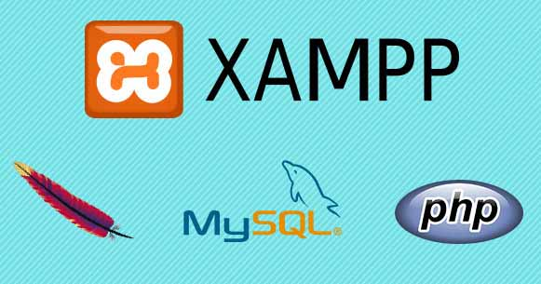

|  |  |
| --- | --- |
| **Hardware(Minimum)**   * **Ram –** 1024 MB * **HDD –** 30GB * **Processor –** Intel Core Core Duo / AMD Athlon * **Accessories –** Keyboard and Mouse | **Software(Recommended)**   * **OS –** Windows * **User Interface –** PHP Framework * **Languages –** PHP 8.0, HTML 5, CSS * **Database -**  MySQL 8.0 |

**SYSTEM ANALYSIS AND DESIGN**

A property analysis report is a valuable tool to understand how your property stacks up in the marketplace. It is also important when making any financial decisions on whether to buy, hold or sell. A proper analysis takes research from multiple resources and making sure all the gathered data is accurate.

Steps:

1. Step 1: Defining the system property. Property name. ...
2. Step 2: Determining required accessibility levels.
3. Step 3: Adding it to system/sepolicy.
4. Step 4: Determining stability requirements.
5. Step 5: Setting properties at build time.
6. Step 6: Access properties at runtime. ...
7. Appendix: Adding vendor-specific properties.



**1)Context Diagram**



**2)Use Case Diagram**



**3)Context Level Diagram**



**4)Class Diagram**



**5)ER Diagram**



**6)Sequence Diagram**



**DATABASE TABLE DESIGN**

Admin Table

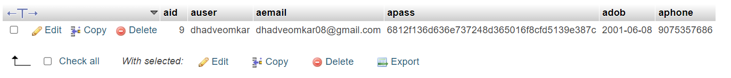

User Table

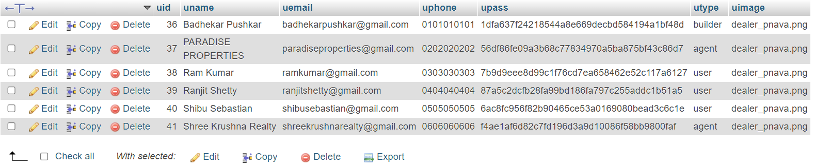

State Table

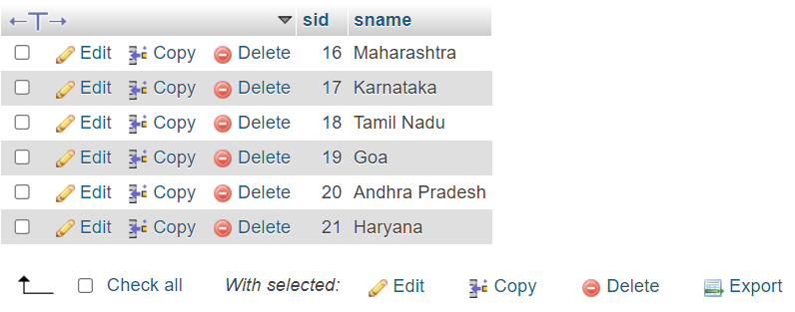

City Table

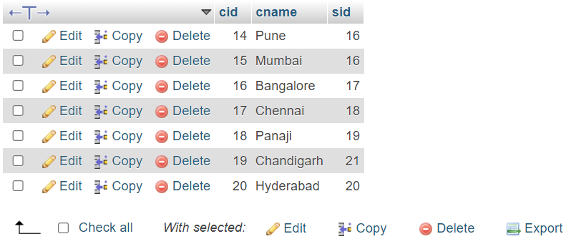

Feedback Table

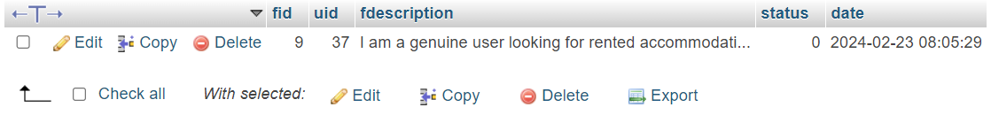

Contact Table

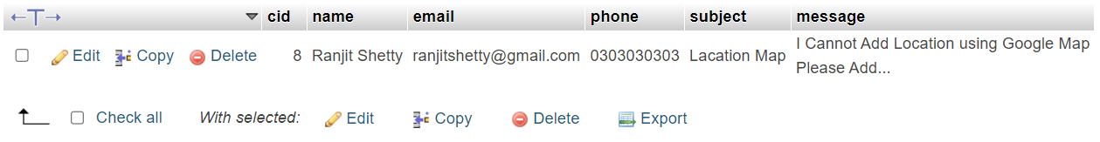

About Table

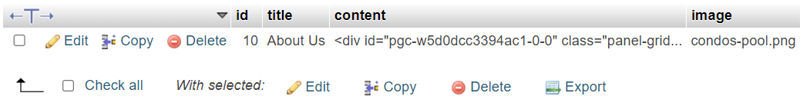

Property Table

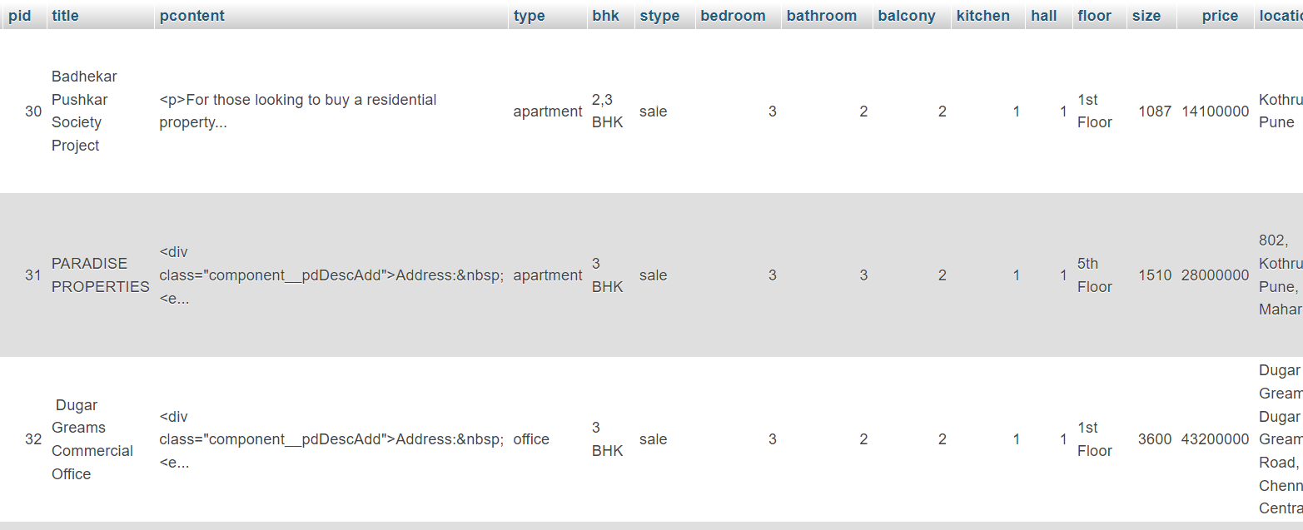



**SCREENSHOTS**

**Admin Base**

Admin Profile

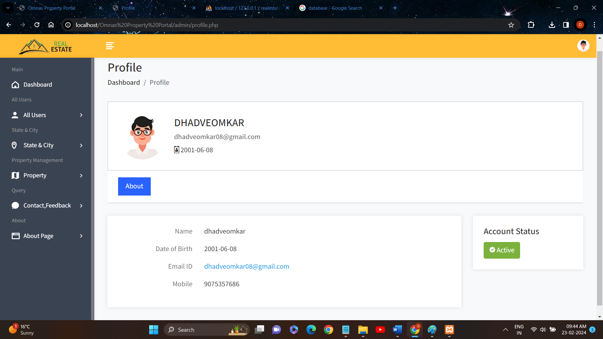

Dashboard

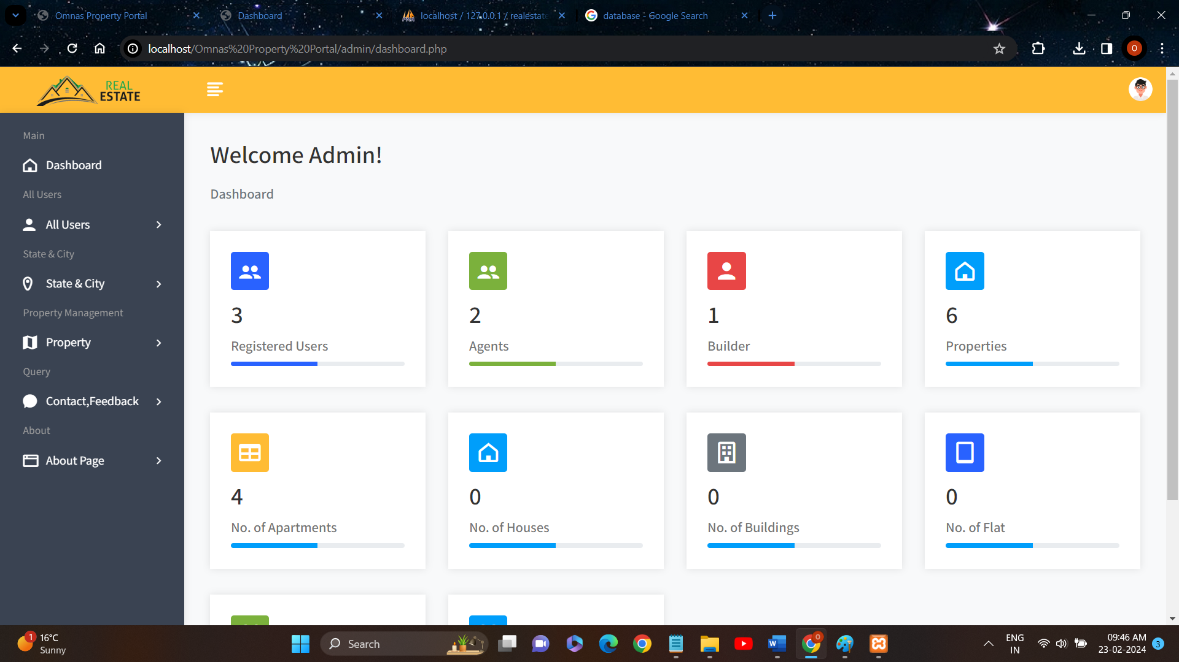

Admin List

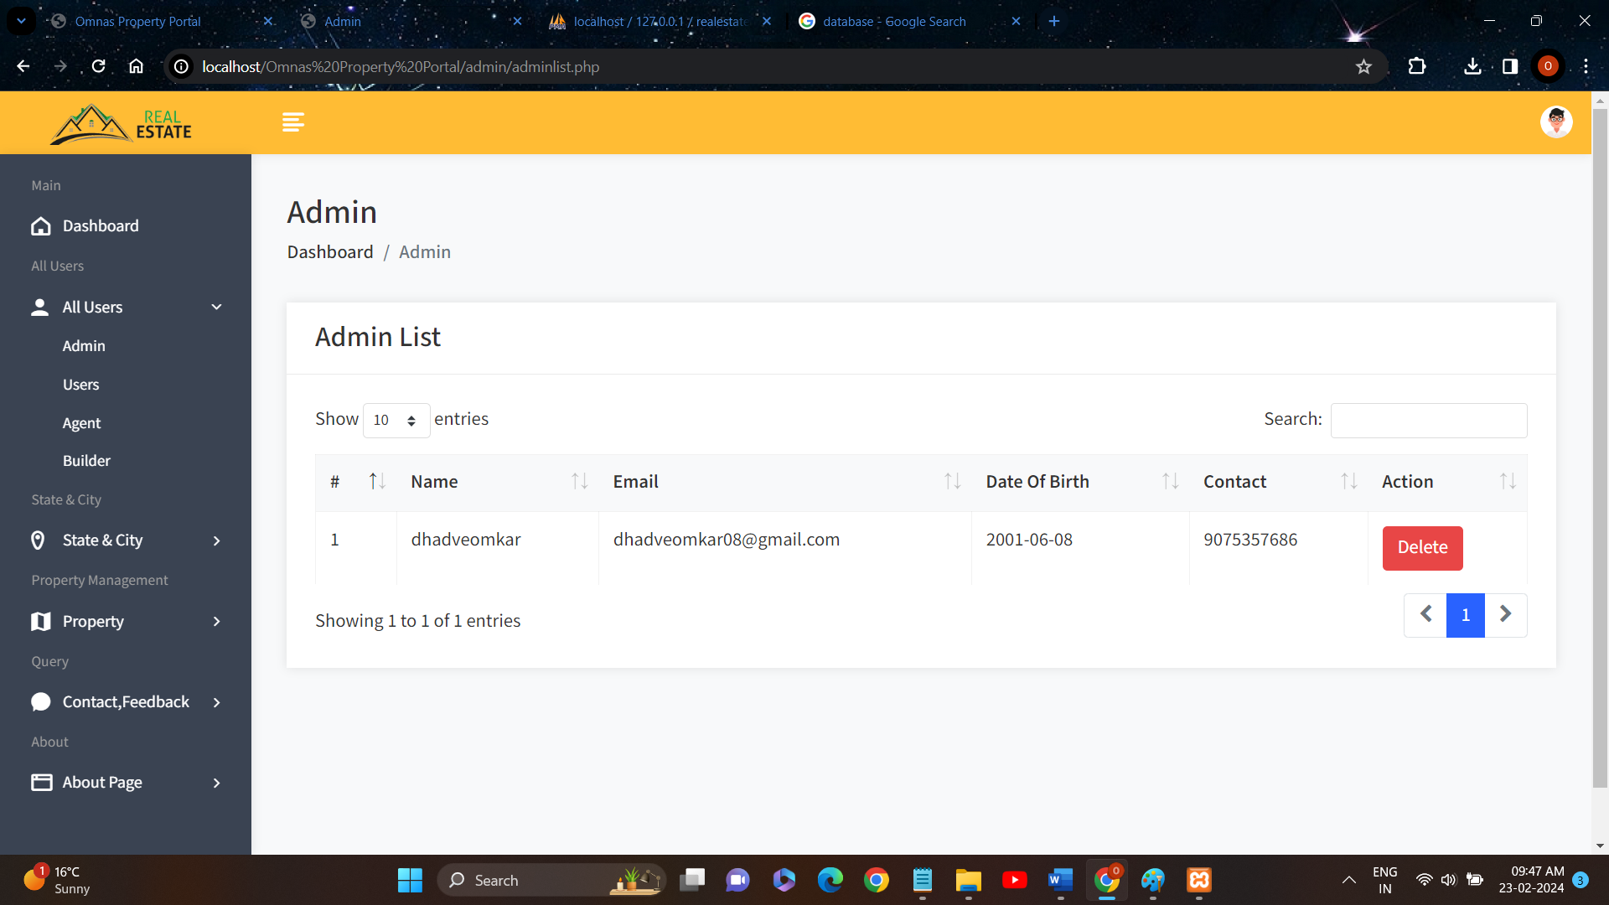

User List

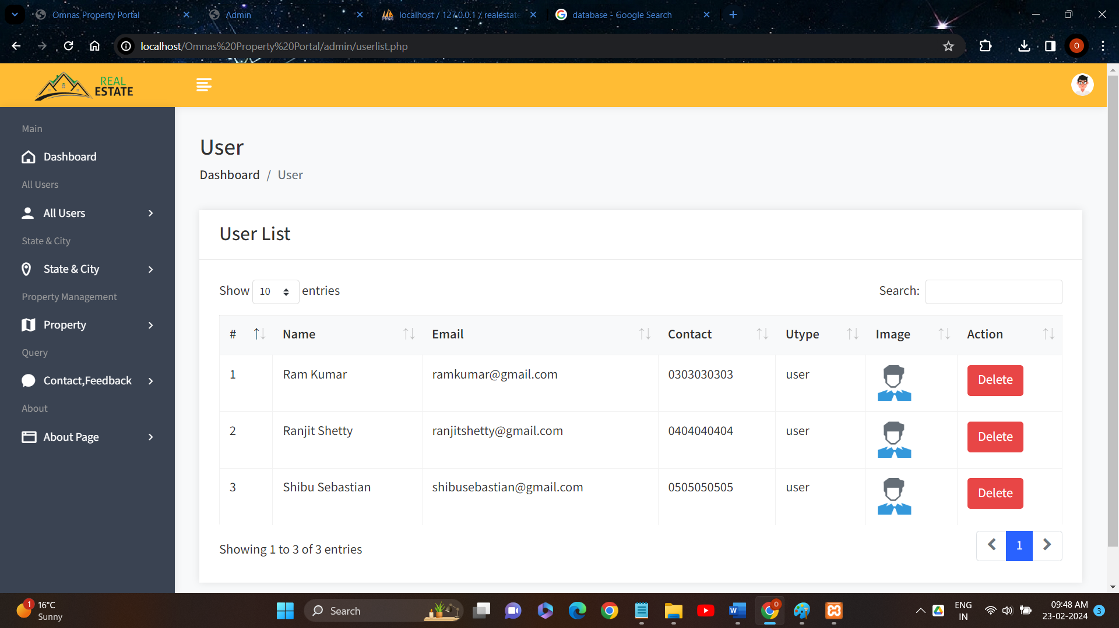

User List

Agent List

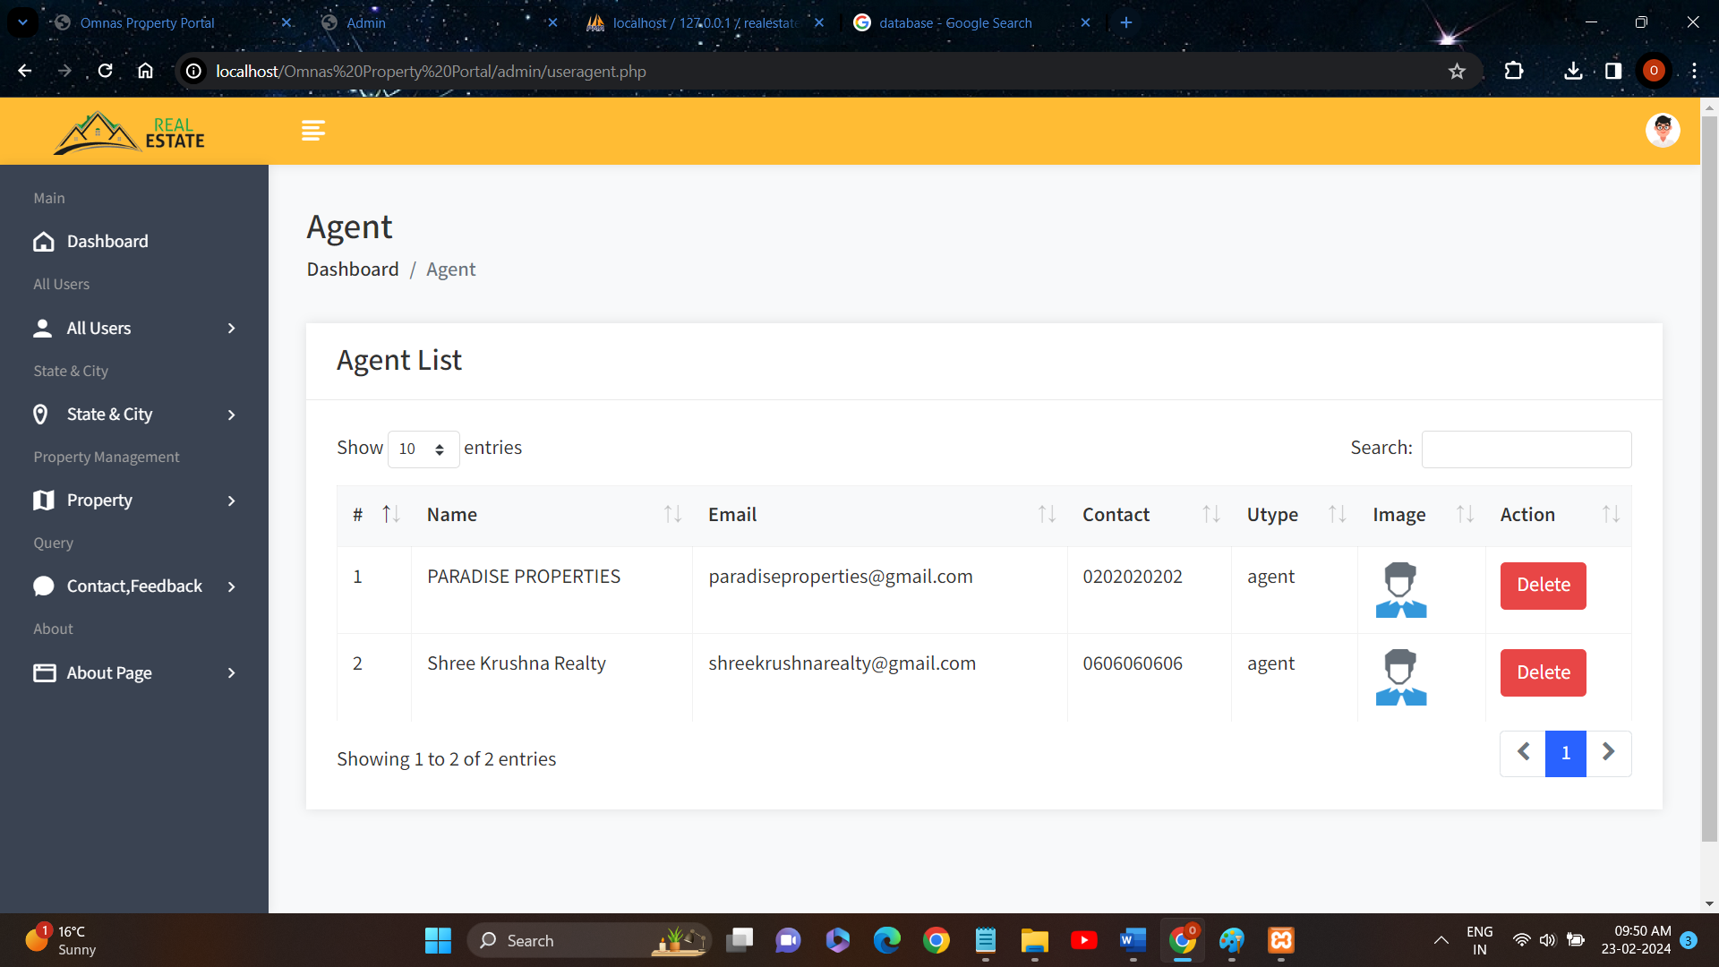

Builder List

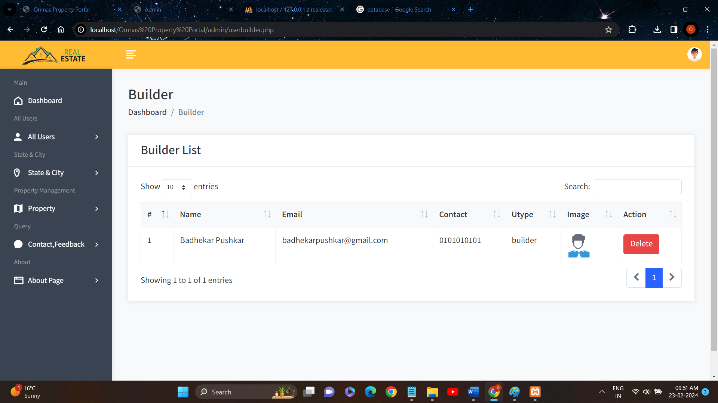

State List

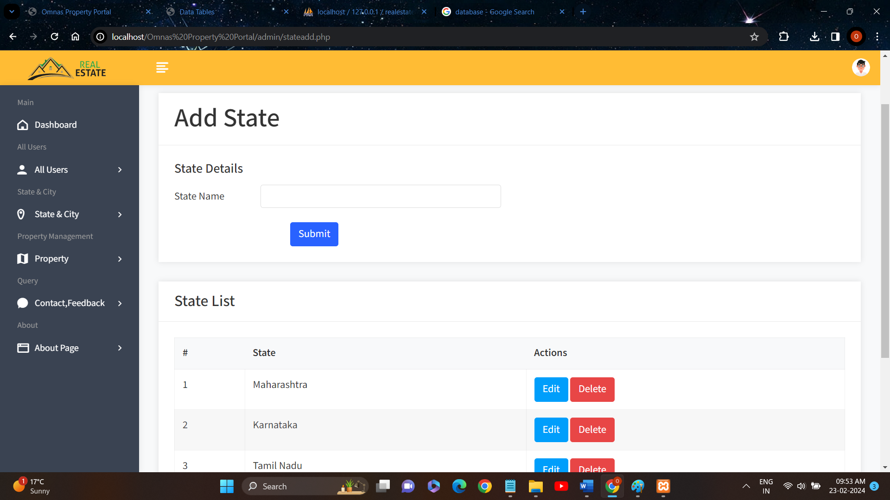

City List

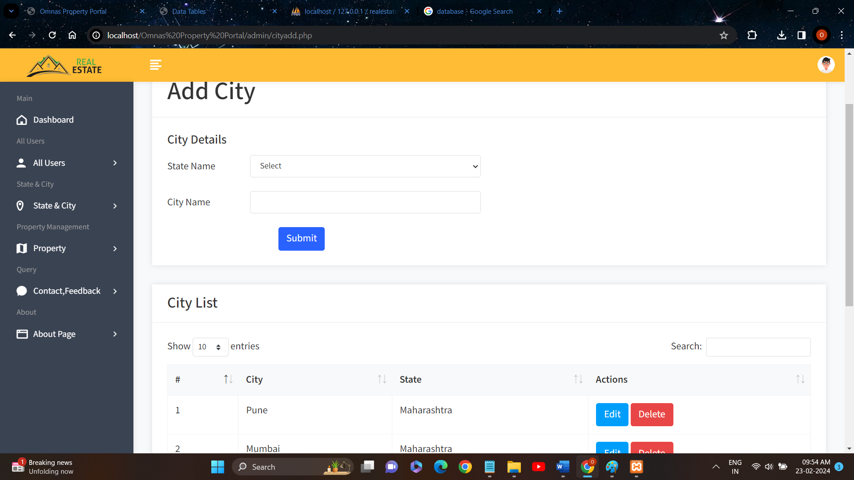

Property List

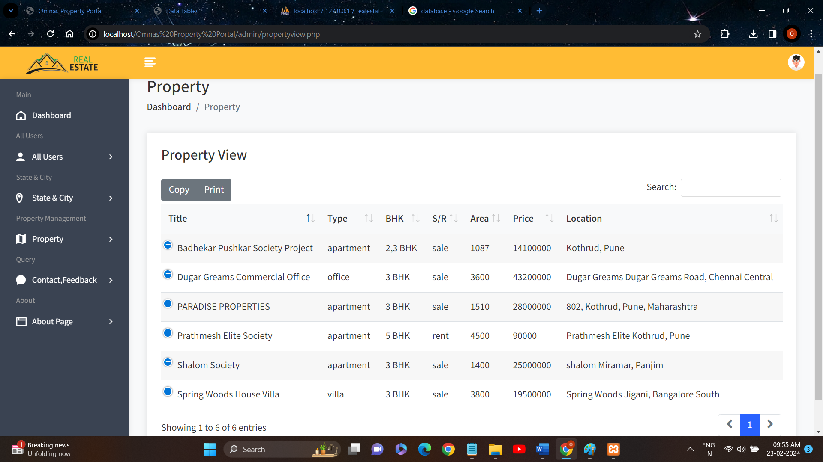

About

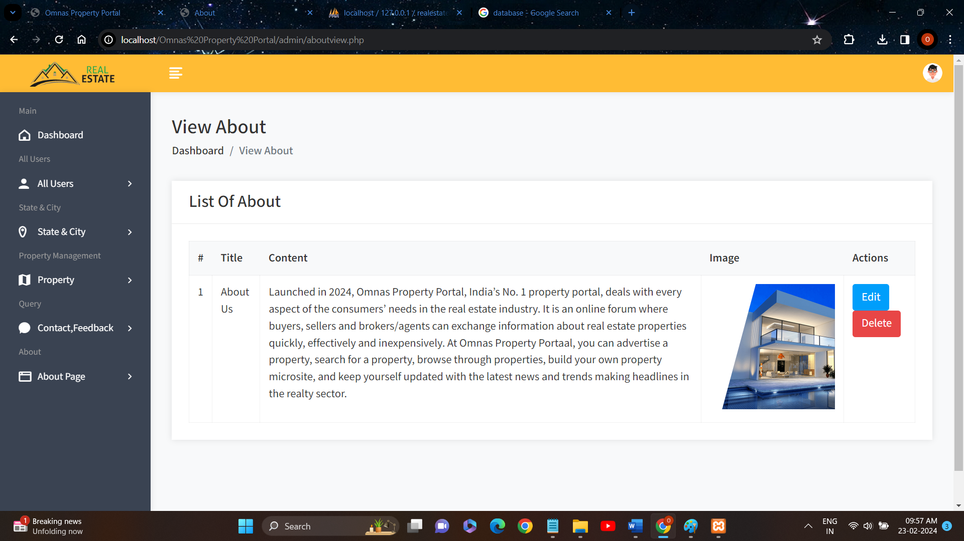

Contact List

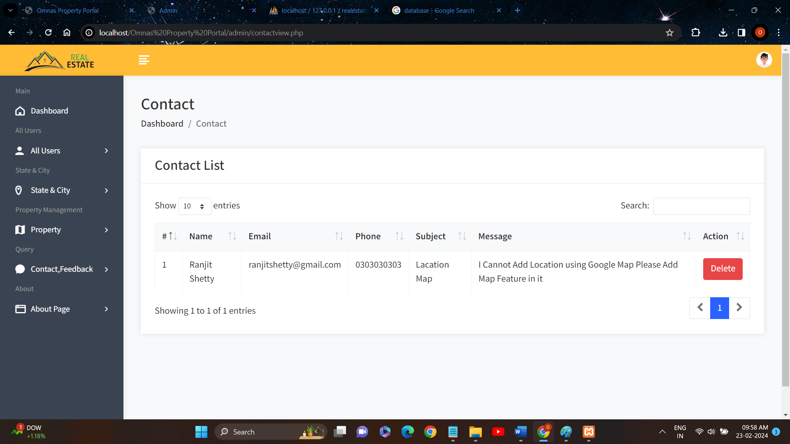

Feedback List



**User Base**

Homepage

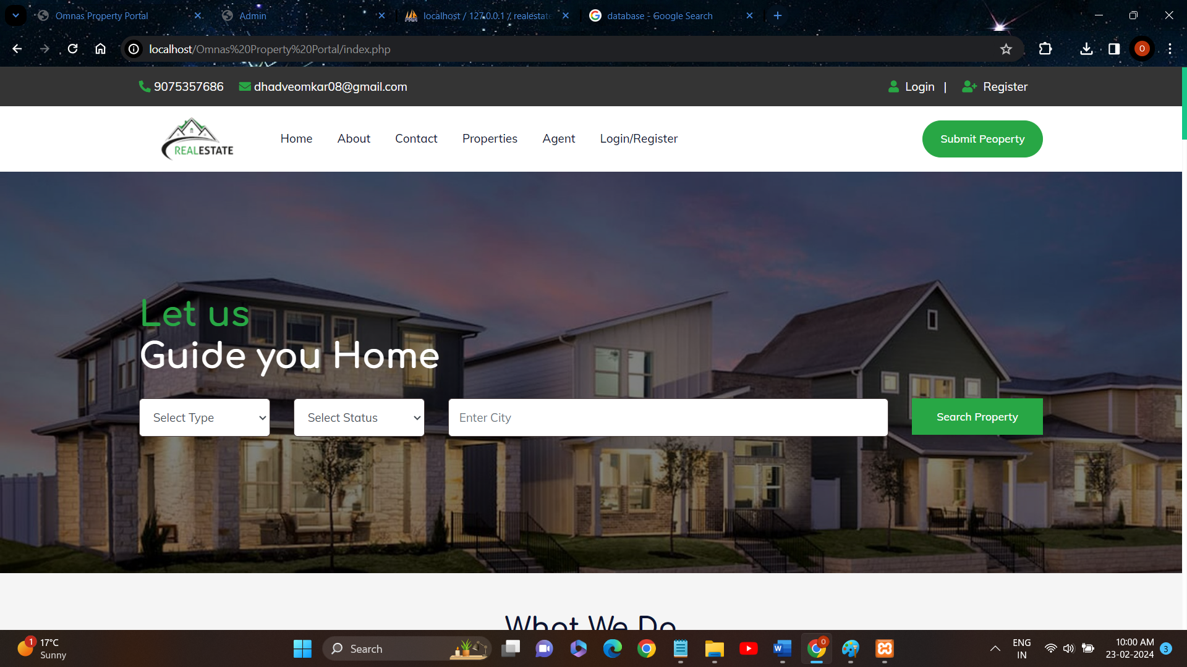

About

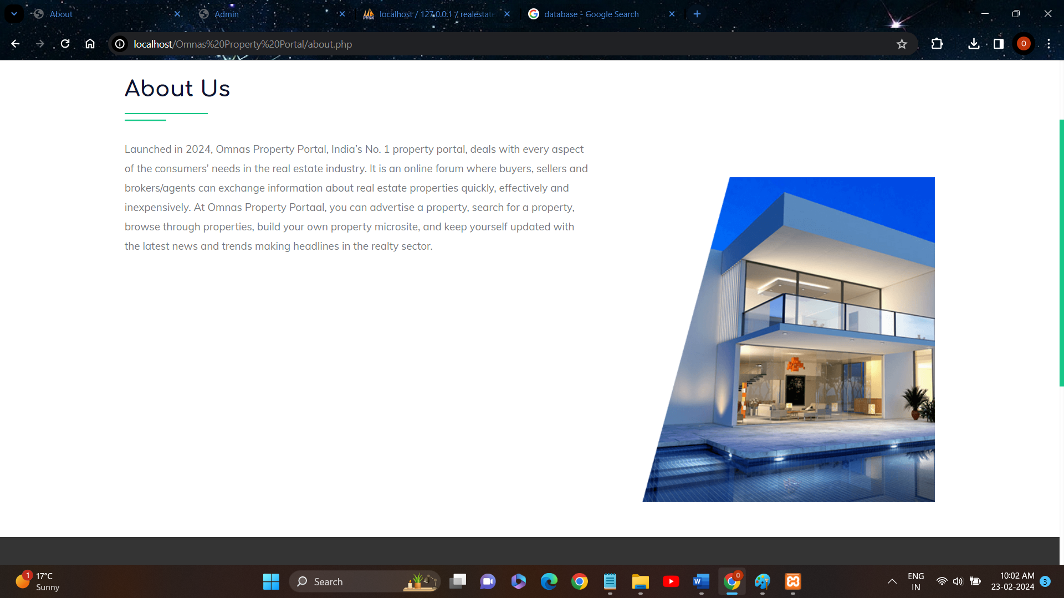

Contact Us

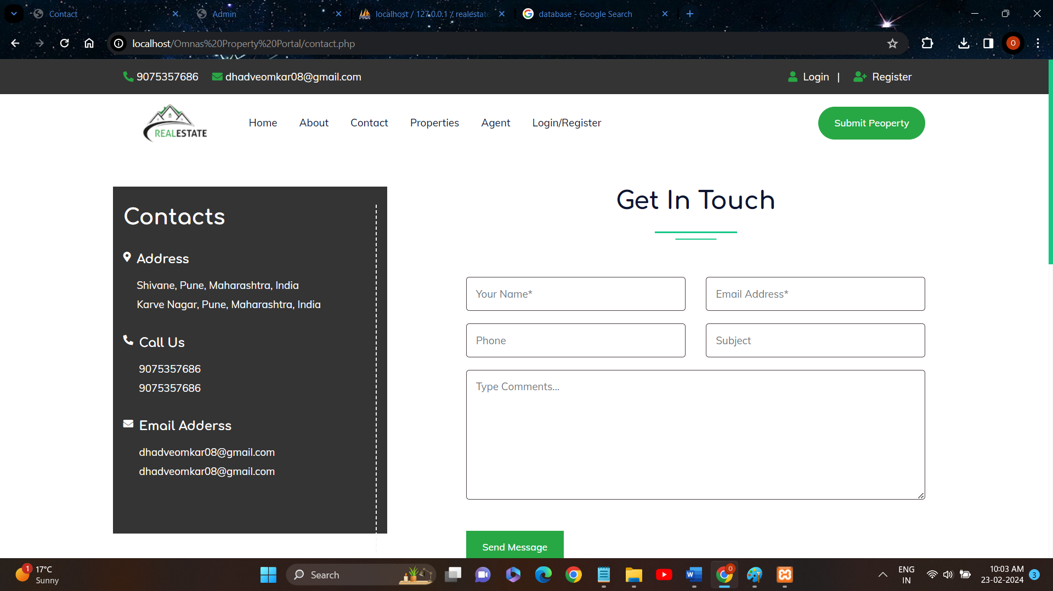

Property

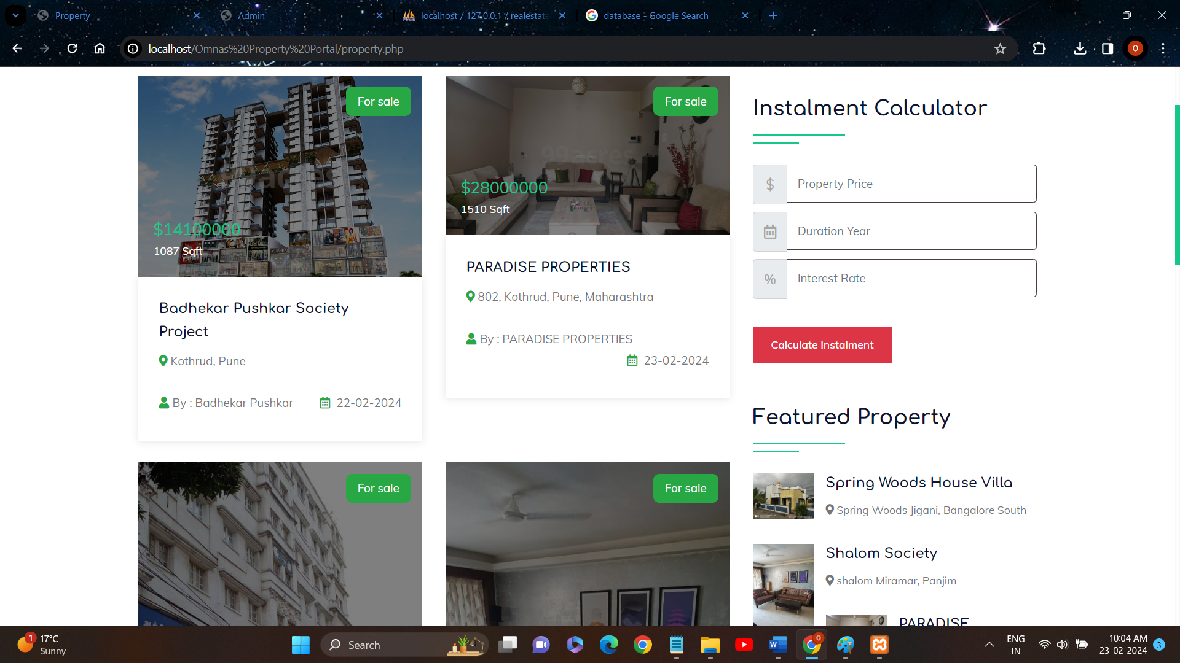

Agent

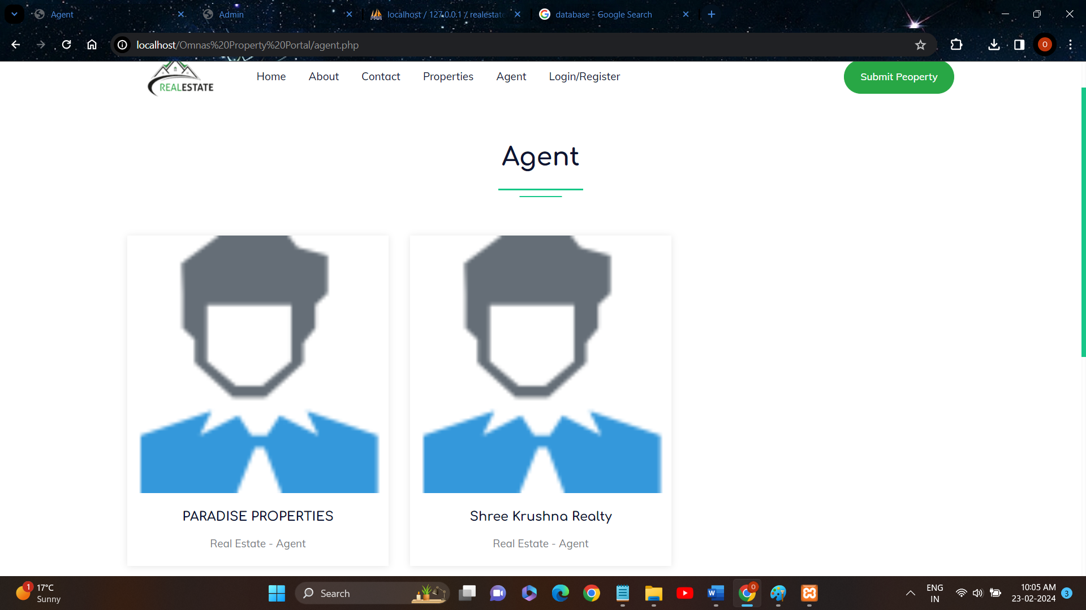

Register

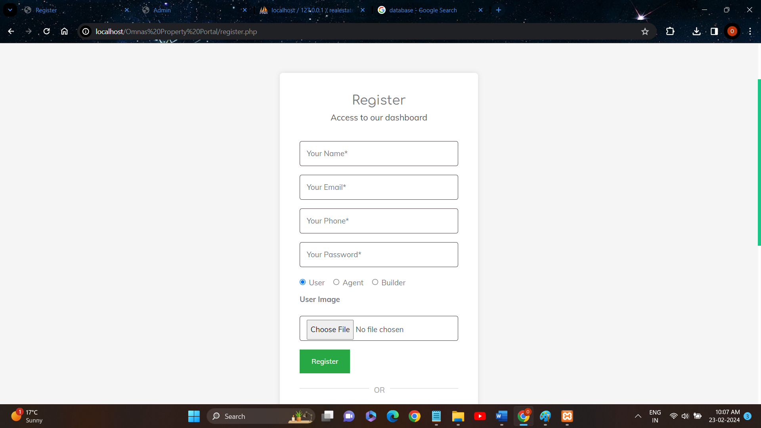

Login

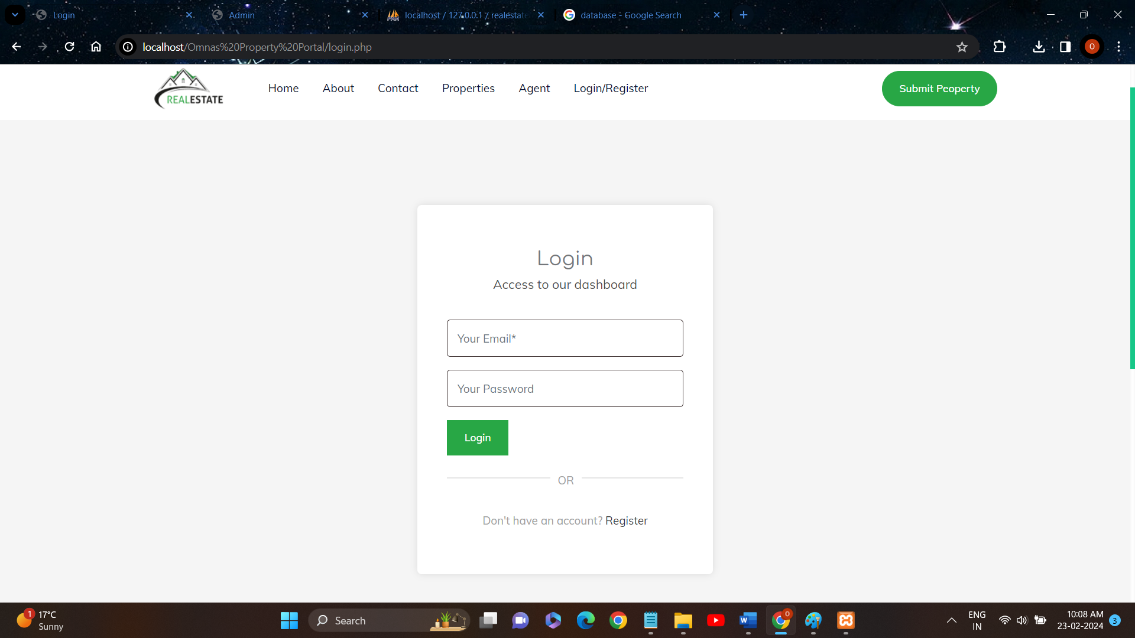

Feedback Form

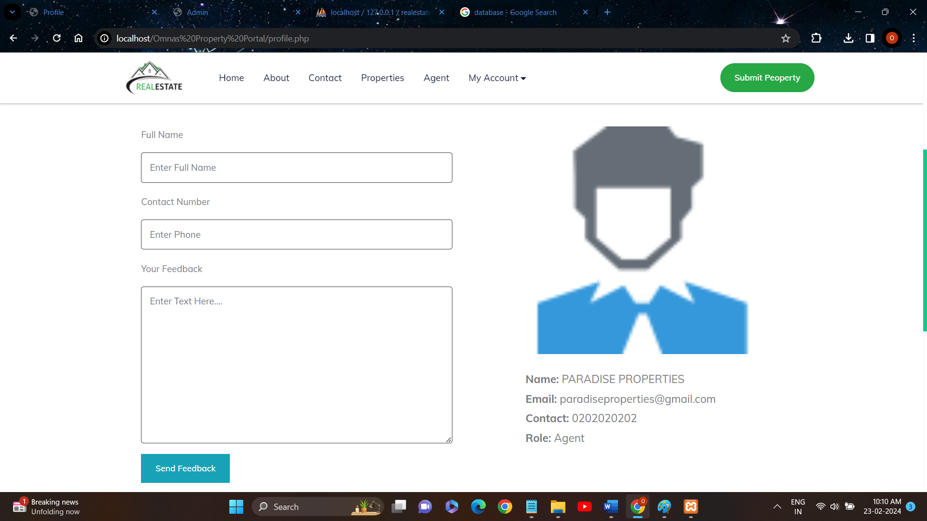

Submit Property Form

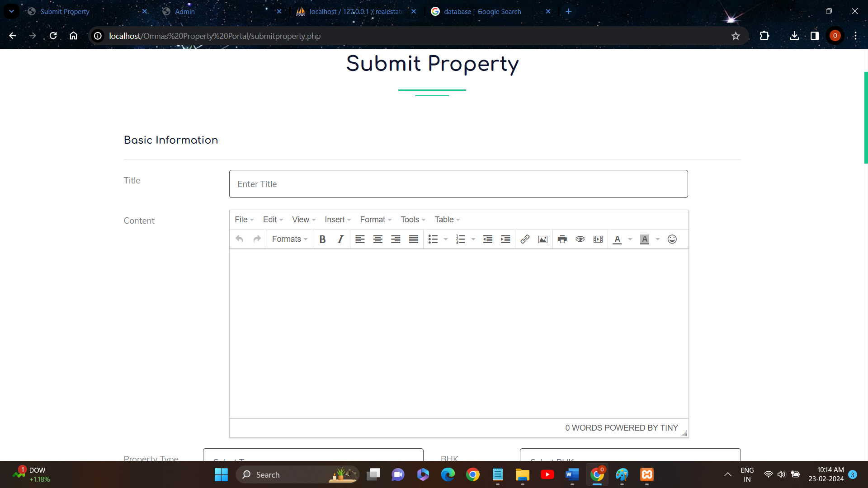

User Listed Property/Update Property

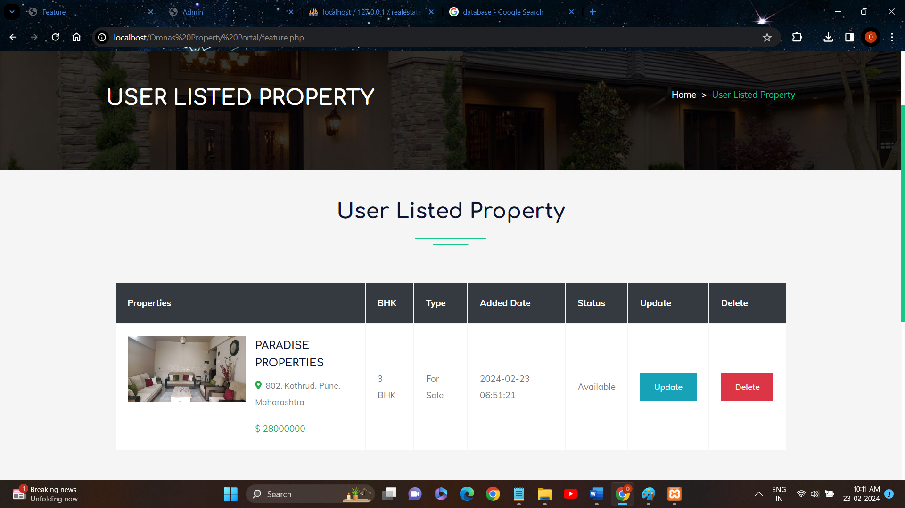

**CONCLUSION**

The project has given lot of practice in a very wide subject like Web Design. This project

has given us a great opportunity to explore our skills, to think towards problem,To accept

them and solved them efficiently. It made us implement everything in practice that we had

learned and also other more useful parts.

The project has given a professional touch towards our learning. It has made us

implements not only WEB DESIGNING but also our knowledge on different subject like ERP

and CRM and others, It also increases our communication skill, made us handle different

types of client. It has played a major role in our academic career. In technical term to say it

has acted as an “interface” between our academic and industry. It has made us more

productive, respecting a need of user, understanding the problems and making them

understand the project, and it has acted as “gateway” towards the corporate world.

It made us understand different factors which are required to build fully fledged project.

On personal level it has flourished our skills made us more courage to tackle the

problems, made us given the best in us. After completing this project we felt, we could be

called as “True I.T professionals”.

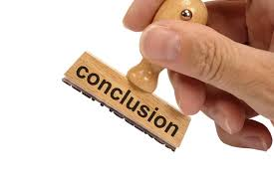

**BIBLIOGRAPHY**

1)99acres

2)NoBroker

3)YouTube

4)GeeksforGeeks

5)CodeAstro

Thank You!!!

